**Cisco Switch Fault Reporting**

* Logon to the Cisco Portal

[https://www.cisco.com/c/en_uk/support/index.html](https://eur03.safelinks.protection.outlook.com/?url=https%3A%2F%2Fwww.cisco.com%2Fc%2Fen_uk%2Fsupport%2Findex.html&data=04%7C01%7Candrew.kay%40fgh-uk.com%7Cc34c35b39bbb4f259c1208d886520adb%7C59a654dea35c4cec8e8282da18d1548a%7C0%7C0%7C637407034206652336%7CUnknown%7CTWFpbGZsb3d8eyJWIjoiMC4wLjAwMDAiLCJQIjoiV2luMzIiLCJBTiI6Ik1haWwiLCJXVCI6Mn0%3D%7C1000&sdata=vGmvURlYFSi90VpN%2BhKDwEcJD2JWTn0fkY4XYQIGxlQ%3D&reserved=0)

* User Name

[Cisco@fgh-uk.com](mailto:Cisco@fgh-uk.com)

* P/Word

!QAZ2wsx

* Select the Open New Case option in My Support

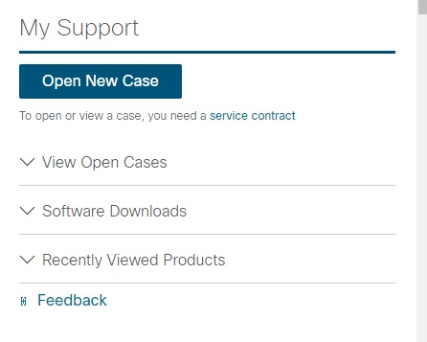

* In the new Support Case Manager window select the Open New Case option

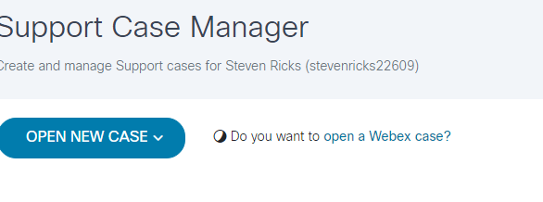

* In the new box - click on the open case button

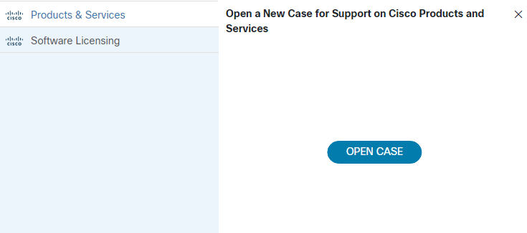

* Fill in the required fields and follow onscreen instructions